AMALIY MASHG’ULOT. MANTIQIY FUNKSIYALAR: ROSTLIK JADVALLARI VA MANTIQIY CHIZMALAR. MANTIQIY VA O’ZGARTIRUVCHI CHIZMALAR TUZILISHI XOSSALARI.

Mantiqiy mulohazalar uchun turli hil algebraic belgilashlar kiritish mumkin:[1]

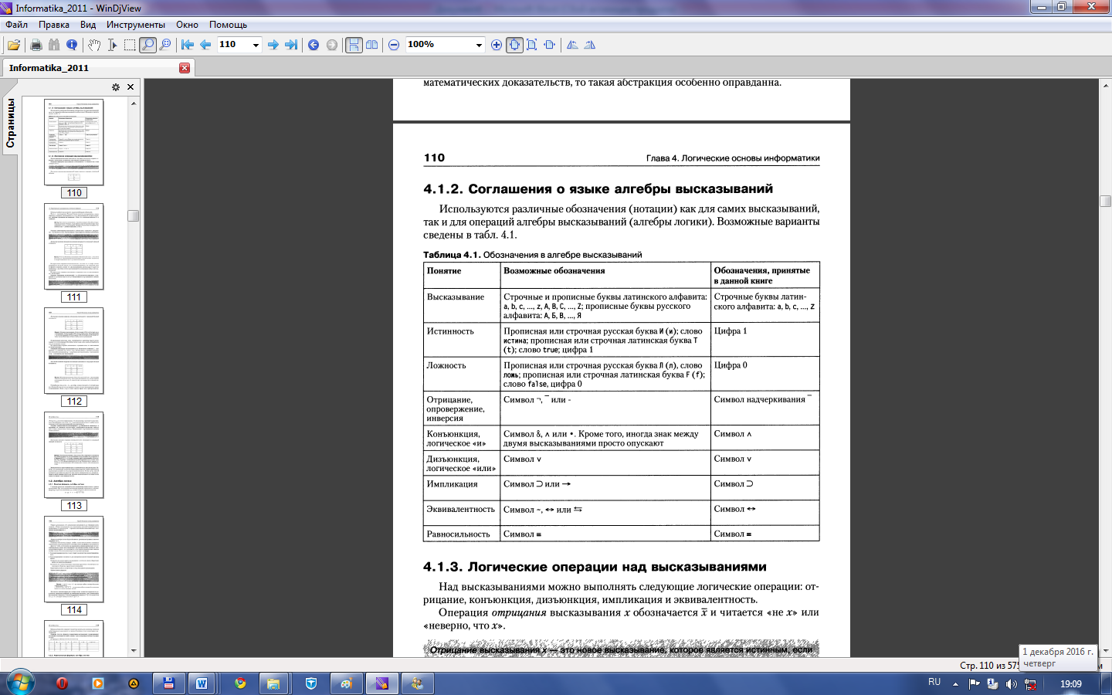

Topshiriq – 1. A/\ (B \/ ¬B /\¬C) formula uchun rostlik jadvalini tuzing.

Mantiqiy о‘zgaruvchilar soni 3 ga teng, demak qatorlar soni - 23 = 8.

Formuladagi mantiqiy amallar soni 5 ga teng, mantiqiy о‘zgaruvchilar soni 3 ga teng, demak ustunlar soni - 3 + 5 = 8.

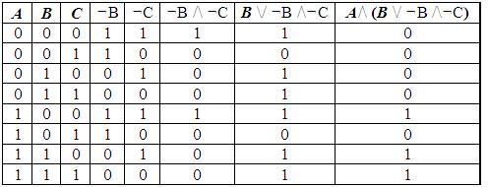

 Topshiriq – 2.  F(A,V)=(A\/V)/\(¬A\/¬V) mantiqiy ifodaning rosligini aniqlang.

1. Ifodada ikkita A va V о‘zgaruvchilar ishtirok etgan (n=2).

2.  msatr=2n, m=22=4 ta satr.

3. Formulada 5 ta mantiqiy amal mavjud.

4. Amallar ketma-ketligini kо‘rib chiqamiz:

1) A\/ V;  2) ¬A;  3) ¬V;  4) ¬A\/¬V;  5) (A\/ V)/\(¬A\/¬V).

5. Kustunlar=n+5=2+5=7 ta ustun.

|  |  |  |  |  |  |  |
| --- | --- | --- | --- | --- | --- | --- |
| A | V | A\/ V | ¬A | ¬V | ¬A\/¬V | F |
| 0 | 0 | 0 | 1 | 1 | 1 | 0 |
| 0 | 1 | 1 | 1 | 0 | 1 | 1 |
| 1 | 0 | 1 | 0 | 1 | 1 | 1 |
| 1 | 1 | 1 | 0 | 0 | 0 | 0 |

Hulosa: mantiqiy ifoda F(0,1)=1 va F(1,0)=1 da faqat rost qiymatni qabul qiladi.

Topshiriq – 3.  F=(A\/B)/\¬S ifoda uchun rostlik jadvalini tuzing.

Ushbu funksiyada uchta – A, V, S о‘zgaruvchilar ishtirok etgan.

Jadval satrlari soni = 23 =8

Formulada 3 ta mantiqiy amal mavjud.

Amallar ketma-ketligini kо‘rib chiqamiz:

1) A\/ V;  2) ¬S; 3) (AVB) /\ ¬S  .

Jadvalda ustunlar soni = 3 + 3 = 6

|  |  |  |  |  |  |
| --- | --- | --- | --- | --- | --- |
| A | V | S | A\/B | ¬S | (A\/B) /\ ¬S |
| 0 | 0 | 0 | 0 | 1 | 0 |
| 0 | 0 | 1 | 0 | 0 | 0 |
| 0 | 1 | 0 | 1 | 1 | 1 |
| 0 | 1 | 1 | 1 | 0 | 0 |
| 1 | 0 | 0 | 1 | 1 | 1 |
| 1 | 0 | 1 | 1 | 0 | 0 |
| 1 | 1 | 0 | 1 | 1 | 1 |
| 1 | 1 | 1 | 1 | 0 | 0 |

Topshiriq – 4. F = ((S \/V) =>  V) /\ (A /\ V) => V mantiqiy ifodaning rosligini aniqlang.

1. Ifodada ikkita A, V va C о‘zgaruvchilar ishtirok etgan (n=3).

2.  msatr=2n, m=23=8 ta satr.

3. Formulada 4 ta mantiqiy amal mavjud.

4. Amallar ketma-ketligini kо‘rib chiqamiz:

1) S \/V;  2) (S \/V) =>  V;  3) A /\ V;  4) (S \/V) =>  V) /\ (A /\ V);  5) (A\/ V)/\(¬A\/¬V).

5. Kustunlar=n+5=3+5=8 ta ustun.

Bu formulaning rostlik jadvalini tuzamiz

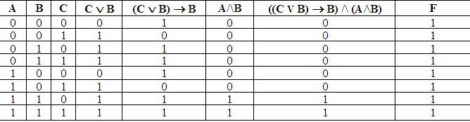

Javob: formula aynan rost.

Topshiriq – 5. F mantiqiy ifodaning argumenti sifatida uchta X, Y, Z argumentlardan biri belgilangan.

F ifoda uchun quyidagi rostlik jadvalining qismi berilgan:

|  |  |  |  |
| --- | --- | --- | --- |
| X | Y | Z | F |
| 0 | 0 | 0 | 1 |
| 0 | 0 | 1 | 0 |
| 0 | 1 | 0 | 1 |

F qanda funksiyalardan iborat?

¬X/\¬Y/\Z

¬X\/¬Y\/Z

X\/Y\/¬Z

X\/Y\/Z

 Yechim: (1-variant, rostlik jadvali orqali):

Ushbu topshiriqning yechimini topish uchun 4 ta funksiyaning har biri uchun boshlang‘ich о‘zgaruvchilar tо‘plami uchun javobda berilgan rostlik jadvalining qismini qurish va uni dastlabki rostlik jadvali bilan taqqoslash mumkin:

|  |  |  |  |  |  |  |  |  |  |  |
| --- | --- | --- | --- | --- | --- | --- | --- | --- | --- | --- |
| X | Y | Z | F | ¬X | ¬Y | ¬Z | ¬X/\¬Y/\Z | ¬X\/¬Y\/Z | X\/Y\/¬Z | X\/Y\/Z |
| 0 | 0 | 0 | 1 | 1 | 1 | 1 | 0 | 1 | 1 | 0 |
| 0 | 0 | 1 | 0 | 1 | 1 | 0 | 1 | 1 | 0 | 1 |
| 0 | 1 | 0 | 1 | 1 | 0 | 1 | 0 | 1 | 1 | 1 |

 Kо‘rinib turibdiki, berilgan F funksiyaning qiymatlari X\/Y\/¬Z ifodaning qiymatlari bilan mos tushgan. Demak, tо‘g‘ri javob – 3.

Javob: 3

Topshiriq – 6.  http://ido.tsu.ru/schools/physmat/data/res/informatika3/text/images/for1.gififodaning rostlik jadvalini tuzing.

Yechish.

Ushbu ifodada 2 ta – A va B mulohaza majud. Ular uchun avval ularning inkorini, ya’ni A ning inkori Ā va B ning inkori http://ido.tsu.ru/schools/physmat/data/res/informatika3/text/images/for2.gifni aniqlash kerak. Sо‘ngra http://ido.tsu.ru/schools/physmat/data/res/informatika3/text/images/for3.gifmantiqiy kо‘paytirishni, keyin http://ido.tsu.ru/schools/physmat/data/res/informatika3/text/images/for4.gif mantiqiy qо‘shish, oxirida esa http://ido.tsu.ru/schools/physmat/data/res/informatika3/text/images/for1.gifmantiqiy inkor amallarini bajarish kerak. Rostlik jadvalimiz 7 ustun va 5 satrdan iborat bо‘ladi.

|  |  |  |  |  |  |  |
| --- | --- | --- | --- | --- | --- | --- |
| A | B | Ā | http://ido.tsu.ru/schools/physmat/data/res/informatika3/text/images/for2.gif | http://ido.tsu.ru/schools/physmat/data/res/informatika3/text/images/for3.gif | http://ido.tsu.ru/schools/physmat/data/res/informatika3/text/images/for4.gif | http://ido.tsu.ru/schools/physmat/data/res/informatika3/text/images/for1.gif |
|  |  |  |  |  |  |  |
|  |  |  |  |  |  |  |
|  |  |  |  |  |  |  |
|  |  |  |  |  |  |  |

A va B о‘zgaruvchilar uchun barcha mulohazalarning mumkin bо‘lgan variantlarini kiritamiz.

|  |  |  |  |  |  |  |
| --- | --- | --- | --- | --- | --- | --- |
| A | B | Ā | http://ido.tsu.ru/schools/physmat/data/res/informatika3/text/images/for2.gif | http://ido.tsu.ru/schools/physmat/data/res/informatika3/text/images/for3.gif | http://ido.tsu.ru/schools/physmat/data/res/informatika3/text/images/for4.gif | http://ido.tsu.ru/schools/physmat/data/res/informatika3/text/images/for1.gif |
| 0 | 0 |  |  |  |  |  |
| 0 | 1 |  |  |  |  |  |
| 1 | 0 |  |  |  |  |  |
| 1 | 1 |  |  |  |  |  |

3- va 4- ustunlarga A va B о‘zgaruvchilarning inkorini kiritamiz.

|  |  |  |  |  |  |  |
| --- | --- | --- | --- | --- | --- | --- |
| A | B | Ā | http://ido.tsu.ru/schools/physmat/data/res/informatika3/text/images/for2.gif | http://ido.tsu.ru/schools/physmat/data/res/informatika3/text/images/for3.gif | http://ido.tsu.ru/schools/physmat/data/res/informatika3/text/images/for4.gif | http://ido.tsu.ru/schools/physmat/data/res/informatika3/text/images/for1.gif |
| 0 | 0 | 1 | 1 |  |  |  |
| 0 | 1 | 1 | 0 |  |  |  |
| 1 | 0 | 0 | 1 |  |  |  |
| 1 | 1 | 0 | 0 |  |  |  |

Sо‘ngra 5-ustunga A va http://ido.tsu.ru/schools/physmat/data/res/informatika3/text/images/for3.gif operandalar uchun http://ido.tsu.ru/schools/physmat/data/res/informatika3/text/images/for3.gifmantiqiy kо‘paytirishdan hosil bо‘lgan natijani kiritamiz.

|  |  |  |  |  |  |  |
| --- | --- | --- | --- | --- | --- | --- |
| A | B | Ā | http://ido.tsu.ru/schools/physmat/data/res/informatika3/text/images/for2.gif | http://ido.tsu.ru/schools/physmat/data/res/informatika3/text/images/for3.gif | http://ido.tsu.ru/schools/physmat/data/res/informatika3/text/images/for4.gif | http://ido.tsu.ru/schools/physmat/data/res/informatika3/text/images/for1.gif |
| 0 | 0 | 1 | 1 | 0 |  |  |
| 0 | 1 | 1 | 0 | 0 |  |  |
| 1 | 0 | 0 | 1 | 1 |  |  |
| 1 | 1 | 0 | 0 | 0 |  |  |

Sо‘ngra 6-ustunga http://ido.tsu.ru/schools/physmat/data/res/informatika3/text/images/for4.gif mantiqiy qо‘shish natijasini kirtamiz.

|  |  |  |  |  |  |  |
| --- | --- | --- | --- | --- | --- | --- |
| A | B | Ā | http://ido.tsu.ru/schools/physmat/data/res/informatika3/text/images/for2.gif | http://ido.tsu.ru/schools/physmat/data/res/informatika3/text/images/for3.gif | http://ido.tsu.ru/schools/physmat/data/res/informatika3/text/images/for4.gif | http://ido.tsu.ru/schools/physmat/data/res/informatika3/text/images/for1.gif |
| 0 | 0 | 1 | 1 | 0 | 1 |  |
| 0 | 1 | 1 | 0 | 0 | 1 |  |
| 1 | 0 | 0 | 1 | 1 | 1 |  |
| 1 | 1 | 0 | 0 | 0 | 0 |  |

Oxirgi ustunga http://ido.tsu.ru/schools/physmat/data/res/informatika3/text/images/for1.gifmantiqiy inkor amallarini bajarishdan hosil bо‘lgan natijalarni kiritamiz.

|  |  |  |  |  |  |  |
| --- | --- | --- | --- | --- | --- | --- |
| A | B | Ā | http://ido.tsu.ru/schools/physmat/data/res/informatika3/text/images/for2.gif | http://ido.tsu.ru/schools/physmat/data/res/informatika3/text/images/for3.gif | http://ido.tsu.ru/schools/physmat/data/res/informatika3/text/images/for4.gif | http://ido.tsu.ru/schools/physmat/data/res/informatika3/text/images/for1.gif |
| 0 | 0 | 1 | 1 | 0 | 1 | 0 |
| 0 | 1 | 1 | 0 | 0 | 1 | 0 |
| 1 | 0 | 0 | 1 | 1 | 1 | 0 |
| 1 | 1 | 0 | 0 | 0 | 0 | 1 |

Javob: Roslik jadvali natijasi quyidagi kо‘rinishga keladi:

|  |  |  |
| --- | --- | --- |
| A | B | http://ido.tsu.ru/schools/physmat/data/res/informatika3/text/images/for1.gif |
| 0 | 0 | 0 |
| 0 | 1 | 0 |
| 1 | 0 | 0 |
| 1 | 1 | 1 |

MUSTAQIL BAJARISH UCHUN TOPSHIRIQLAR:

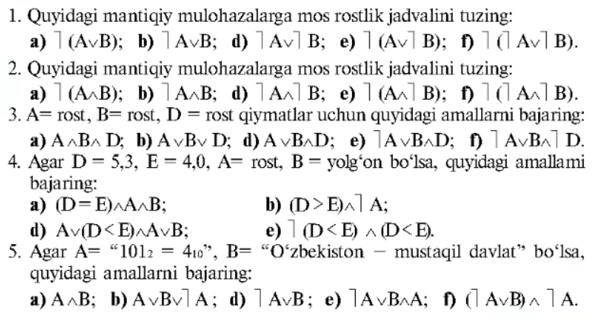

1. Проф. Н.В.Макаровой, В.Б.Волков. Информатика. - М.: 2011 г.(110-с)