**\*Who do you live with?**

**\*Do you get on well with your parents?**

**\*Do you think they understand you?**

**\*What do they mean to you?**

A. Listen to the song and order the following verbs.

Be

Become

Care

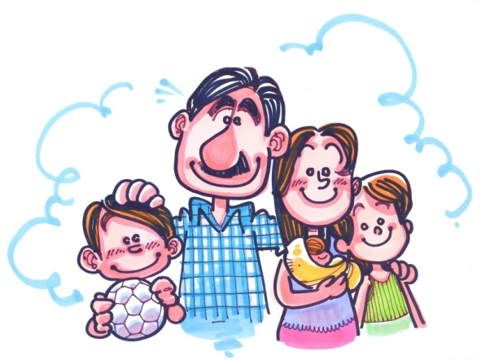Find

Give

Hold

Know

Like

Miss

Notice

Say

See

Spend

Think

ODE TO MY FAMILY

The Cranberries

Doo, doo, doo, doo, doo, doo, doo, doo...

Complete with verbs and auxiliaries in the present form.

Understand the things I __________, ____________ turn away from me, Cause I've spent half my life out there, you wouldn't disagree.   
Do you _________ me? Do you see?

Do you __________ me?   
__________ you like me standing there? Do you notice?   
Do you ____________? Do you see me?

Do you see me? _____________ anyone care?

Choose the personal pronoun you hear.

Unhappiness where's when ***I – she- it*** was young,   
And ***they – we – you*** didn't give a damn,   
'Cause we were raised,   
To see life as fun and take ***she – it- he*** if we can.   
My mother, my mother,   
She hold me, ***she- he – we*** hold me, when I was out there.   
My father, my father,   
***He – She – They*** liked me, oh, he liked me. Does anyone care?

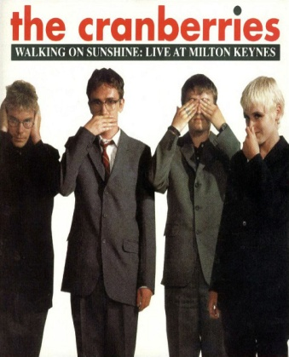  
Understand what I've become, it wasn't my desing.   
And people everywhere think, something better than I am.   
But I miss you, I miss, 'cause I liked it,   
'Cause I liked it, when I was out there. Do you know this?   
Do you know you did not find me. You did not find.   
Does anyone care?

Unhappiness where's when…

Does anyone care?... [X9]   
Doo, doo, doo, doo, doo,

doo, doo, doo...

**\*Who do you live with?**

**\*Do you get on well with your parents?**

**\*Do you think they understand you?**

**\*What do they mean to you?**

A. Listen to the song and order the following verbs.

Be

Become

Care

Find

Give

Hold

Know

Like

Miss

Notice

Say

See

Spend

Think

ODE TO MY FAMILY

The Cranberries

Doo, doo, doo, doo, doo, doo, doo, doo...

Complete with verbs and auxiliaries in the present form.

Understand the things I __________, ____________ turn away from me, Cause I've spent half my life out there, you wouldn't disagree.   
Do you _________ me? Do you see?

Do you __________ me?   
__________ you like me standing there? Do you notice?   
Do you ____________? Do you see me?

Do you see me? _____________ anyone care?

Choose the personal pronoun you hear.

Unhappiness where's when ***I – she- it*** was young,   
And ***they – we – you*** didn't give a damn,   
'Cause we were raised,   
To see life as fun and take ***she – it- he*** if we can.   
My mother, my mother,   
She hold me, ***she- he – we*** hold me, when I was out there.   
My father, my father,   
***He – She – They*** liked me, oh, he liked me. Does anyone care?

  
Understand what I've become, it wasn't my desing.   
And people everywhere think, something better than I am.   
But I miss you, I miss, 'cause I liked it,   
'Cause I liked it, when I was out there. Do you know this?   
Do you know you did not find me. You did not find.   
Does anyone care?

Unhappiness where's when…

Does anyone care?... [X9]   
Doo, doo, doo, doo, doo,

doo, doo, doo...

Doo, doo, doo, doo, doo, doo, doo, doo...   
Understand the things I say, don't turn away from me,   
'Cause I've spent half my life out there, you wouldn't disagree.   
Do you see me? Do you see? Do you like me?   
Do you like me standing there? Do you notice?   
Do you know? Do you see me? Do you see me?   
Does anyone care?   
  
Unhappiness where's when I was young,   
And we didn't give a damn,   
'Cause we were raised,   
To see life as fun and take it if we can.   
My mother, my mother,   
She hold me, she hold me, when I was out there.   
My father, my father,   
He liked me, oh, he liked me. Does anyone care?   
  
Understand what I've become, it wasn't my desing.   
And people ev'rywhere think, something better than I am.   
But I miss you, I miss, 'cause I liked it,   
'Cause I liked it, when I was out there. Do you know this?   
Do you know you did not find me. You did not find.   
Does anyone care?   
  
Unhappiness where's when I was young,   
And we didn't give a damn,   
'Cause we were raised,   
To see life as fun and take it if we can.   
My mother, my mother,   
She hold me, she hold me, when I was out there.   
My father, my father,   
He liked me, oh, he liked me.   
  
Does anyone care?... [X9]   
Doo, doo, doo, doo, doo, doo, doo, doo...

A. Listen to the song and order the following verbs.

Be 8

Become 11

Care 7

Find 14

Give 9

Hold 10

Know 6

Like 4

Miss 13

Notice 5

Say 1

See 3

Spend 2

Think 12