My Family

My grandparents are coming to visit us from Calgary, Alberta. My father is very happy because they are his parents, and he is glad that he will see them. We don't see them very often because Calgary is a long way from Toronto.
My grandparents have two sons: my father and my Uncle Bill. Uncle Bill has a wife -- Aunt Susan. They have a daughter who is my cousin. My cousin is a lot older than I, so we do not have a lot in common. They also have a son who is the same age as me. He is my favorite cousin because we both like the same television shows and the same games.
I have two brothers and one sister. My brothers are both younger than I. They are twins, so they have the same birthday. My sister is one year older than I. People say that my sister and I look alike. We both have blonde hair and blue eyes.
My mother's parents live near us. They are the grandmother and grandfather who visit us often.
My mother does not have any brothers or sisters. She is an only child.
I like it when all my family is together. I don't have a lot of cousins like some people do, but I have fun with my relatives.
My uncle Bill often takes my cousin and me to the movies. I like to take my grandparents for walks so that they can see my school, and they can meet my friends. My parents talk to my brothers, my sister and I a lot. We are a very close-knit family. People who have close families are very lucky.

Say if the sentences are true or false.
- My sister is younger then I .
- My mother's parents live near us.
- I don’t see my dad’s parents very often.
- My father’s grandparents have two sons.
- Uncle Bill has a sister Susan.
- Uncle’s son is the same age as me.
- I have two sisters.
- My mother does not have any brothers or sisters.
- I have a lot of cousins.
- My sister and I look alike.
- Uncle Bill doesn’t take me to the movies.
- My brothers have the same birthday.

Draw the family tree

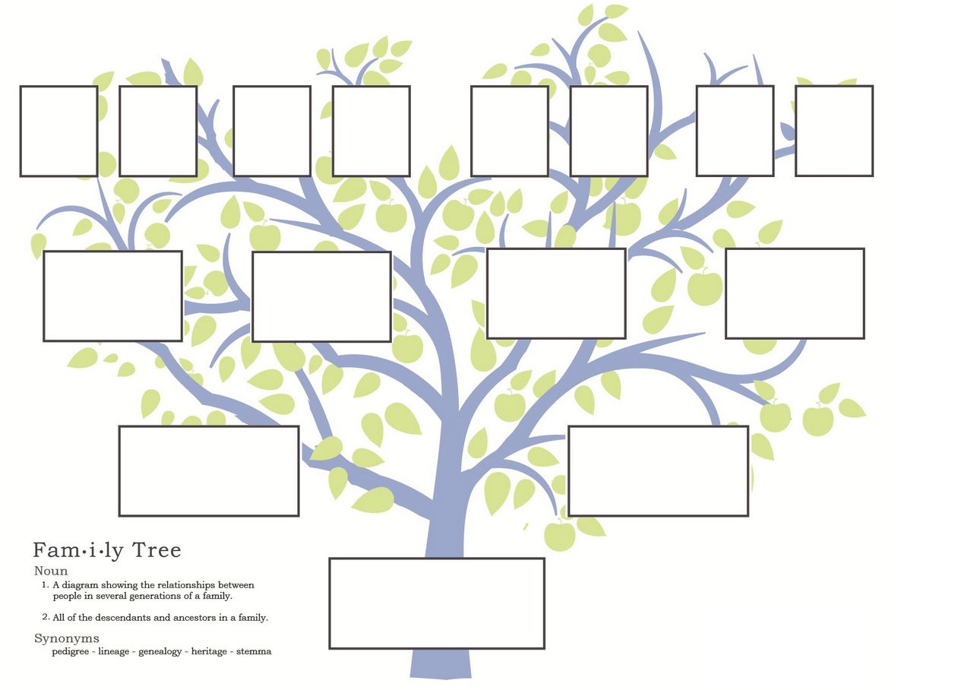

FATHER
MOTHER
SISTER
BROTHER
SON
DOUGHTER
UNCLE
AUNT
GRANDMOTHER
GRANDFATHER
 |  |  |  |  |  |  | B | A | Z | S | L
 |  |  |  |  | I | Y | U | U | E | G | B | G
 |  |  |  | K | O | S | U | N |  |  | T | E | U
 |  |  | N | Q | F | E | J | T |  |  |  | O | D | W
 |  | A | Q | Y | A | A | A | H |  |  |  |  | S | E | G
 |  | R | J | U | L | B | Q | O |  |  |  |  | I | R | Z | Y | S | O | N
 | Z | V | S | N | A | C | D | F | D | C | B | J | S | D | O | D | T | A | G | H
 | U | F | U | C | Y | L | I | Y | W | B | R | O | T | H | E | R | Y | V | W | W | M
Q | B | M | D | L | N | B | P | K | L | U | A | Y | E | Z | Z | T | X | F | Z | N | H
S | M | O | J | E | Q | B | T | M | O | T | H | E | R | U | F | Q | R | A | U | T | U
B | H | U | Y | E | C | D | B | G | B | F | W | J | V | Z | K | E | X | T | L | O | Q
B | N | O | G | R | A | N | D | F | A | T | H | E | R | C | B | A | P | H | J | W | K
 | D | O | U | G | H | T | E | R | G | R | A | N | D | M | O | T | H | E | R | E
 |  | B | C | K | G |  |  |  |  |  |  |  |  |  | Y | J | P | R
 |  |  | B | H |  |  |  |  |  |  |  |  |  |  |  | E | M

